**Table Tennis**

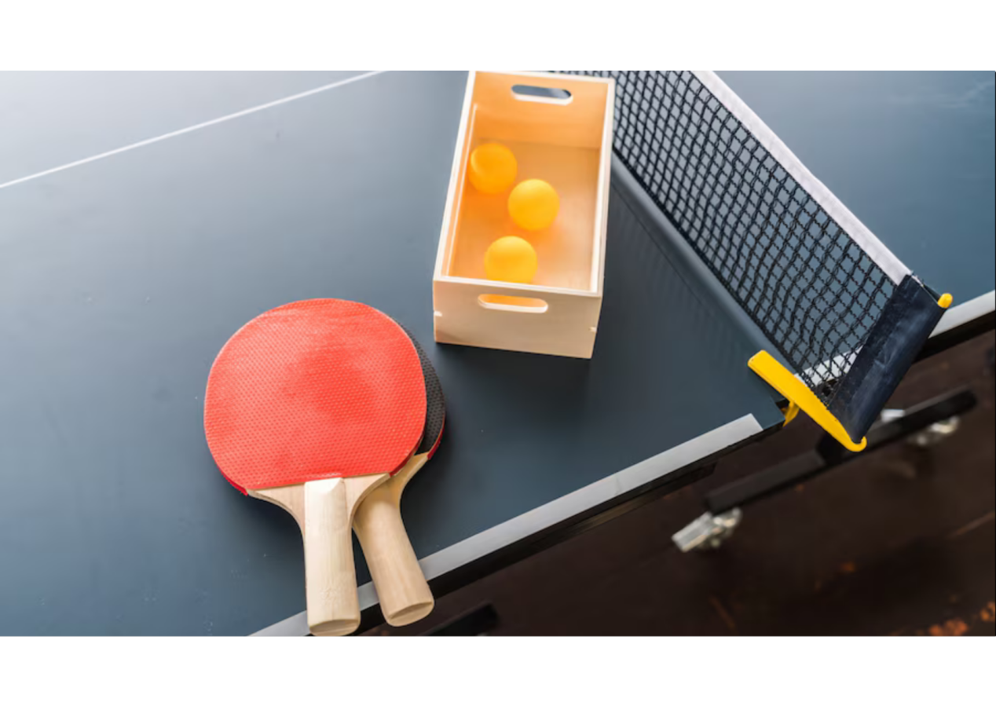

**Description:** A fast-paced sport played on a rectangular table divided by a net.

**How to Play:** Players hit a lightweight ball back and forth using paddles, aiming to score points.

**Location:** Indoor

**Things Needed:** Table tennis table, paddles, ball

**Number of Players:** 2 or 4